**KPI`S**

*BANK LOAN REPORT*

**1)Total Loan Applications**

select COUNT(id)as Total_Loan_Applications from bank_load_data



**2)MTD Loan Applications**

select COUNT(id)as MTD_Total_Loan_Applications from bank_load_data

where MONTH(issue_date) = 12

and YEAR(issue_date)=2021



select COUNT(id)as PMTD_Total_Loan_Applications from bank_load_data

where MONTH(issue_date) = 11

and YEAR(issue_date)=2021



**3)Total Funded Amount**

select SUM(loan_amount)as MTD_Total_Funded_Amount from bank_load_data

where MONTH(issue_date)=12 and YEAR(issue_date)=2021



select SUM(loan_amount)as PMTD_Total_Funded_Amount from bank_load_data

where MONTH(issue_date)=11 and YEAR(issue_date)=2021



**4)Total Amount Received**

select SUM(total_payment) as MTD_Total_Amount_Received from bank_load_data

where MONTH(issue_date)= 12 and YEAR(issue_date)=2021



select SUM(total_payment) as PMTD_Total_Amount_Received from bank_load_data

where MONTH(issue_date)= 11 and YEAR(issue_date)=2021



**5)Average Interest Rate**

select ROUND(avg(int_rate),4)*100 as Avg_Interest_Rate from bank_load_data



select ROUND(avg(int_rate),4)*100 as MTD_Avg_Interest_Rate from bank_load_data

where MONTH(issue_date)=12 and YEAR(issue_date)=2021



select ROUND(avg(int_rate),4)*100 as PMTD_Avg_Interest_Rate from bank_load_data

where MONTH(issue_date)=11 and YEAR(issue_date)=2021



**6)Average Debt-to_Income Ratio(DTI)**

select ROUND(AVG(dti),4)*100 as Avg_DTI from bank_load_data



select ROUND(AVG(dti),4)*100 as MTD_Avg_DTI from bank_load_data

where MONTH(issue_date)=12 and YEAR(issue_date)=2021



select ROUND(AVG(dti),4)*100 as PMTD_Avg_DTI from bank_load_data

where MONTH(issue_date)=11 and YEAR(issue_date)=2021



*Good Loan vs Bad Loan KPI`s*

GOOD LOAN ISSUED:

**1)Good Loan Application Percentage**

select

(COUNT(case when loan_status = 'Fully Paid' or loan_status='Current' then id end)*100)

/

COUNT(id) as Good_Loan_Percentage

from bank_load_data



**2) Good Loan Application**

select COUNT(id) as Good_Loan_Applications from bank_load_data

where loan_status = 'Fully Paid' or loan_status='Current'



**3)Good Loan Funded Amount**

select sum(loan_amount) as Good_Loan_Funded_Amount from bank_load_data

where loan_status = 'Fully Paid' or loan_status='Current'



**4)Good Loan Total Received Amount**

select sum(total_payment) as Good_Loan_Received_Amount from bank_load_data

where loan_status = 'Fully Paid' or loan_status='Current'



BAD LOAN ISSUED:

**1)Bad Loan Application Percentage**

select

(COUNT(case when loan_status='Charged off' then id end )*100.0)/

COUNT(id) as Bad_Loan_Percentage

from bank_load_data



**2)Bad Loan Applications**

select COUNT(id) as Bad_Loan_Applications from bank_load_data

where loan_status='Charged Off'



**3)Bad Loan Funded Amount**

select SUM(loan_amount) as Bad_Loan_Funded_Amount from bank_load_data

where loan_status='Charged Off'



**4)Bad Loan Amount Received**

select SUM(total_payment) as Bad_Loan_Amount_Received from bank_load_data

where loan_status='Charged Off'



*LOAN STATUS GRID VIEW*

select

loan_status,

count(id) as LoanCount,

sum(total_payment) as Total_Amount_Received,

SUM(loan_amount)as Total_Funded_Amount,

avg(int_rate*100)as Interest_Rate,

AVG(dti*100)as DTI

from bank_load_data

group by loan_status

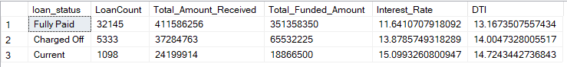

select

loan_status,

sum(total_payment) as MTD_Total_Amount_Received,

SUM(loan_amount)as MTD_Total_Funded_Amount

from bank_load_data

where MONTH(issue_date)=12

group by loan_status

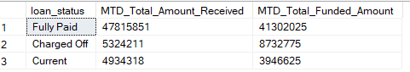

*CHARTS*

**1)Monthly trend by issue date**

select

MONTH(issue_date) as Month_Number,

DATENAME(MONTH,issue_date)as Month_Name,

COUNT(id)as Total_Loan_Applications,

SUM(loan_amount) as Total_Funded_Amount,

SUM(total_payment)as Total_Received_Amount

from bank_load_data

group by MONTH(issue_date),DATENAME(MONTH,issue_date)

order by MONTH(issue_date)

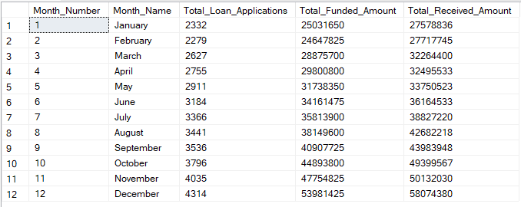

**2)Regional Analysis by State**

SELECT

address_state AS State,

COUNT(id) AS Total_Loan_Applications,

SUM(loan_amount) AS Total_Funded_Amount,

SUM(total_payment) AS Total_Amount_Received

FROM bank_loan_data

GROUP BY address_state

ORDER BY address_state

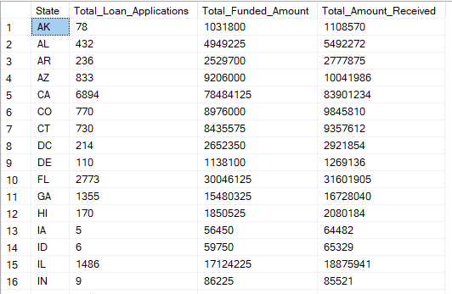

**3)Loan Term Analysis**

SELECT

term AS Term,

COUNT(id) AS Total_Loan_Applications,

SUM(loan_amount) AS Total_Funded_Amount,

SUM(total_payment) AS Total_Amount_Received

FROM bank_load_data

GROUP BY term

ORDER BY term

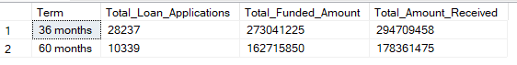

**4)Employee Length Analysis**

SELECT

emp_length AS Employee_Length,

COUNT(id) AS Total_Loan_Applications,

SUM(loan_amount) AS Total_Funded_Amount,

SUM(total_payment) AS Total_Amount_Received

FROM bank_load_data

GROUP BY emp_length

ORDER BY emp_length

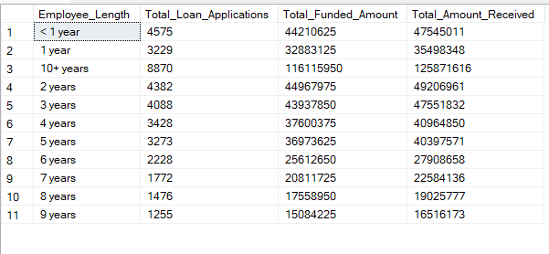

**5)Loan Purpose Breakdown**

SELECT

purpose AS PURPOSE,

COUNT(id) AS Total_Loan_Applications,

SUM(loan_amount) AS Total_Funded_Amount,

SUM(total_payment) AS Total_Amount_Received

FROM bank_load_data

GROUP BY purpose

ORDER BY purpose

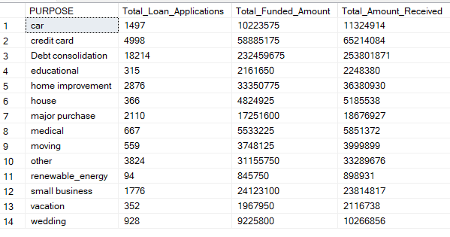

**6)Home Ownership Analysis**

SELECT

home_ownership AS Home_Ownership,

COUNT(id) AS Total_Loan_Applications,

SUM(loan_amount) AS Total_Funded_Amount,

SUM(total_payment) AS Total_Amount_Received

FROM bank_load_data

GROUP BY home_ownership

ORDER BY home_ownership

